MLA0105 - Artificial Intelligence and Expert Systems for Gaming
Experiment 36: Facts
Code:
likes(ram, mango).
girl(seema).
Likes(bill, cindy).
color(rose, red).
owns(john, gold).
Output:
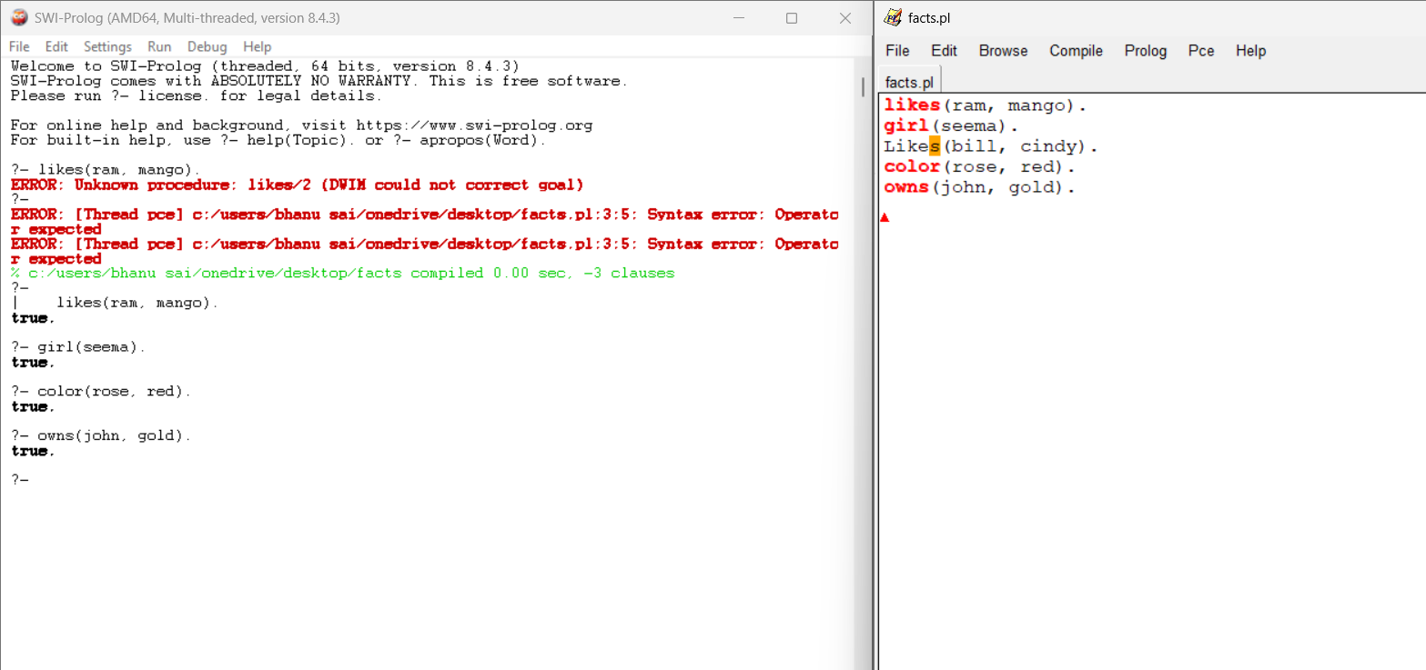

Experiment 37: Sum of integers
Code:
% sum_up_to_n(N, Sum).
sum_up_to_n(1, 1) :- !.
sum_up_to_n(N, Sum) :-
N > 1,
N1 is N - 1,
sum_up_to_n(N1, Temp),
Sum is Temp + N.
Output:
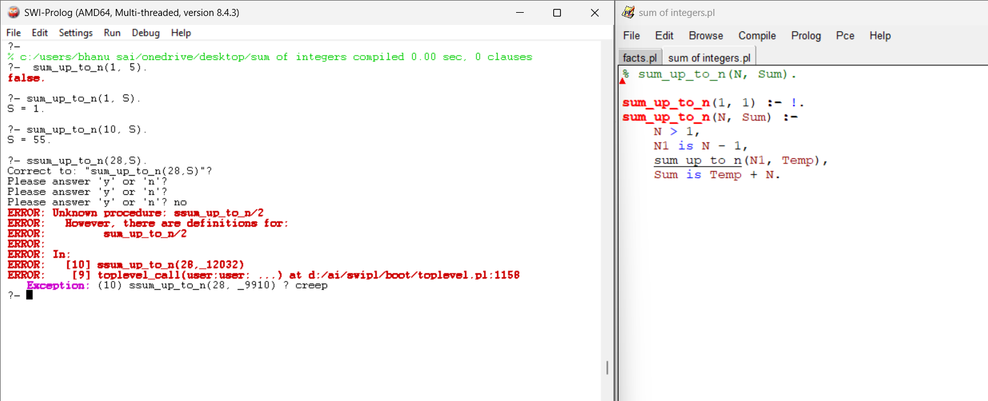

Experiment 38: chess
Code:
perm([], []).
perm(L, [H|T]) :-
select(H, L, R),
perm(R, T).
safe([]).
safe([Q|Others]) :-
safe(Others),
no_attack(Q, Others, 1).
no_attack(_, [], _).
no_attack(Q, [Q1|Rest], D) :-
Q =\= Q1 + D,
Q =\= Q1 - D,
D1 is D + 1,
no_attack(Q, Rest, D1).
four_queens(Solution) :-
perm([1,2,3,4], Solution),
safe(Solution).

Output:
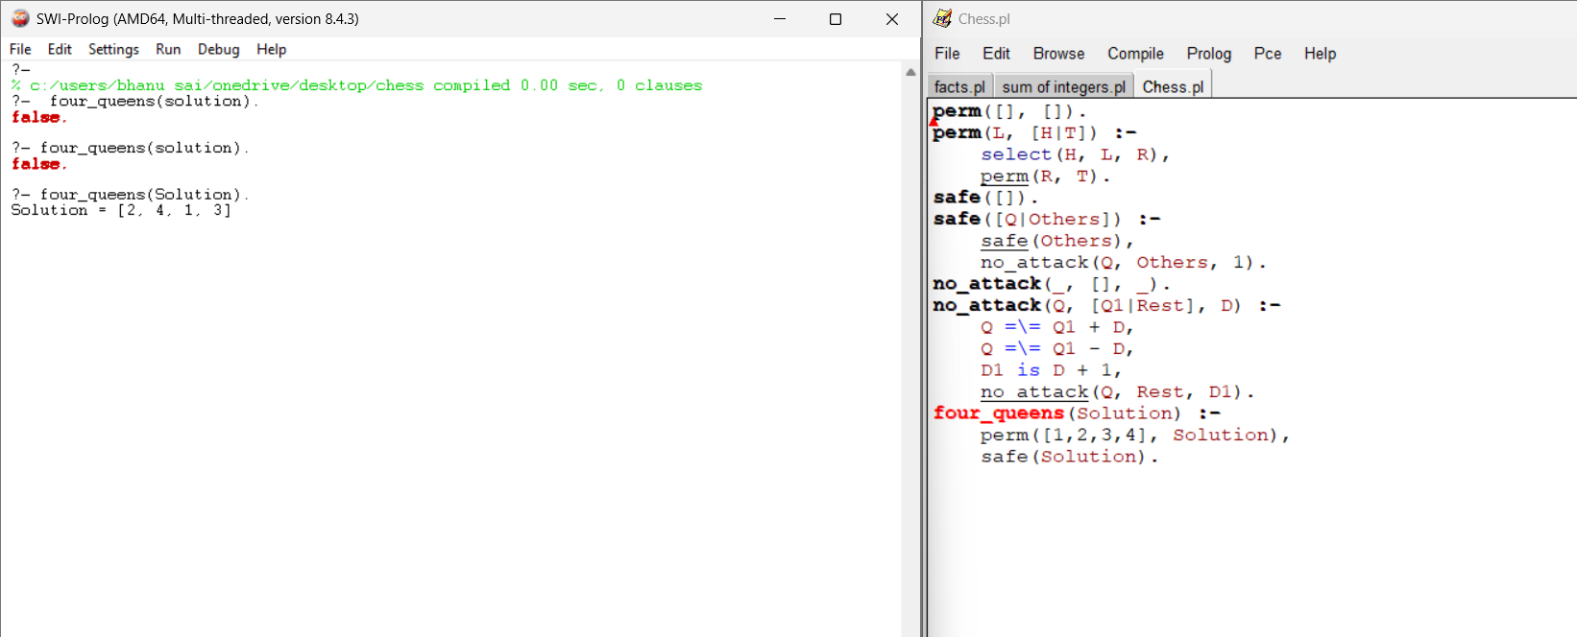

Experiment 39: Factorial Using Recursion

Code:
% Base case:
factorial(0, 1).
% Recursive case:
factorial(N, F) :-
N > 0,
N1 is N - 1,
factorial(N1, F1),
F is N * F1. C<0.
Output:
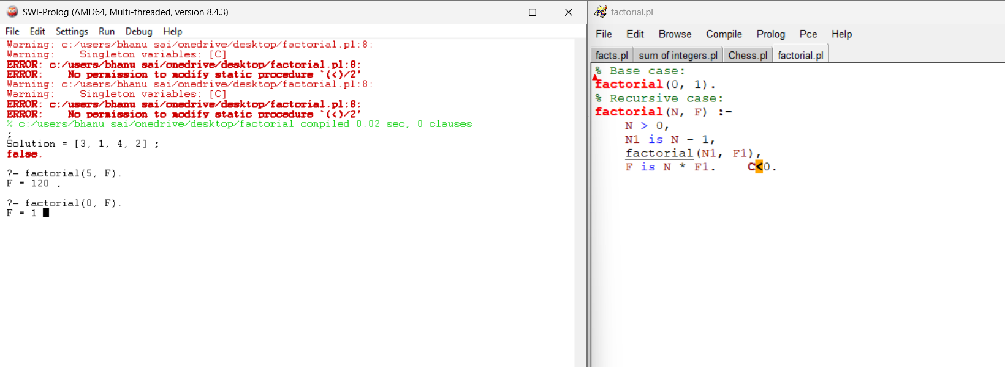
Experiment 40: Fibonacci

Code:
fibonacci(0, 0).
fibonacci(1, 1).
fibonacci(N, F) :-
N > 1,
N1 is N - 1,
N2 is N - 2,
fibonacci(N1, F1),
fibonacci(N2, F2),
F is F1 + F2.
Output:
